Ideation Phase
Define the Problem Statements

Date | 09 January 2026
Project Name | Calculating Family Expenses using Service Now
Maximum Marks | 2 Marks

Customer Problem Statement Template:
Families often struggle to manage and calculate their daily and monthly expenses efficiently. Manual tracking methods using notebooks or spreadsheets are time-consuming, error-prone, and lack real-time insights. Users find it difficult to categorize spending, monitor budgets, and make informed financial decisions. There is a need for an automated and user-friendly solution that simplifies expense entry, categorization, and calculation. By developing a Family Expense Management System using ServiceNow, we aim to help users gain better financial control, reduce errors, and make smarter budgeting decisions with ease.
Example:
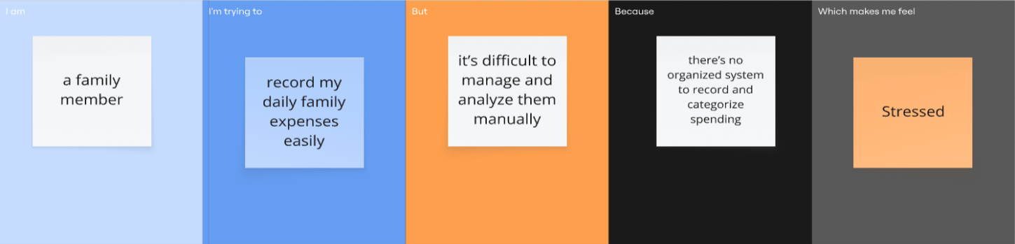

Problem Statement (PS) | I am (Customer) | I’m trying to | But | Because | Which makes me feel
PS-1 | a family member | record my daily family expenses easily | it’s difficult to manage and analyze them manually | there’s no organized system to record and categorize spending | Stressed
PS-2 | a working parent | monitor recurring payments and identify unnecessary costs | I don’t get alerts or visual insights about my expenses | there’s no smart system to automatically analyze and report my spending | anxious

